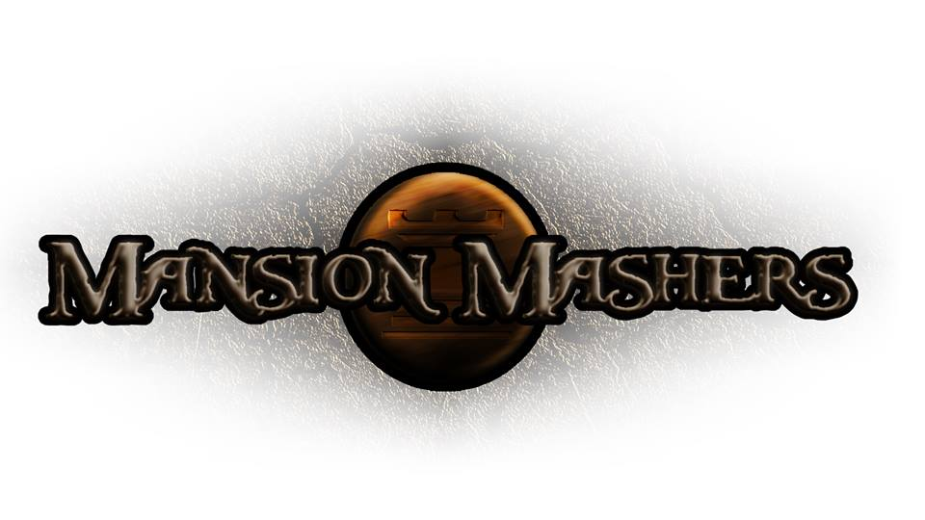**Weekly Production Report**

**Week 4**

**January 30, 2014**

**By Juli Gregg**

**High Concept**:

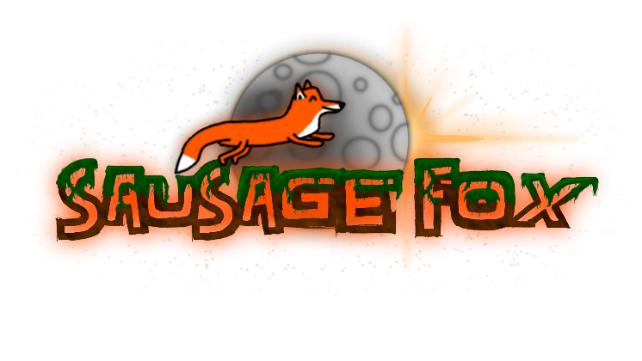A 2-D cartoon fantasy dungeon crawler side-scrolling hack and slash game.

**Producer:**

Juli Gregg

**Tech Director**:

Dan Muller

**Game Designer**:

Luke Conlon

**Project Manager**:

Kaden Nugent

Project Status:

Green

Current Milestone:

Concept/Engine Proof

Accomplishments:

|  |  |
| --- | --- |
| **Juli Gregg:** | Finished adding a FrameRate controller. Added to the current math library for Matrix3 and Vector2. Created background art assets for introduction level. Mapped out tutorial design. |
| **Dan Muller:** | Finished updating platform collision. Finished object creation handing. Documented all source and header files to Doxygen format. Removed all warnings and errors from the week. Added a collision box struct, collision with collision boxes, bouncing platforms, restitution calculating, and is in the process of restructuring object creation and management. |
| **Luke Conlon:** | Added functions to handle player movement animation by use math instead of art frames. Is in the process of creating character designs (has 2/4 main characters done). Mapped out tutorial design. Fixed HUD. |
| **Kaden Nugent:** | Is in the process of testing a Texture Manager he finished making this week. Working on restructuring object creation and management. |

Objectives:

|  |  |
| --- | --- |
| **Juli Gregg:** | Continue to update math libraries and work on implementing FMOD into project. Map out more levels. |
| **Dan Muller:** | Begin working on infrastructure for what is needed in tutorial level. Implement text, text pop-ups and floating text. Enhance object and collision interaction including weapon object and interactions. |
| **Luke Conlon:** | Work on finishing main character designs and add details to existing background art assets. Implement level designs and create tutorial level. |
| **Kaden Nugent:** | Create a Character Manager and other sprite/object handling features. |

Group Accomplishments:

|  |  |
| --- | --- |
| **Weekly Group Meeting** | Together we went through and developed in depth character design for main characters, two bosses, story characters, and basic enemy types. Began to plan out next three weeks until Engine Proof including goals we want to achieve for this and future milestones. Discussed added code. |
| **Repository**  **Commit Stats** | This week: 63 commits  This month: 235 commits |

Group Objectives:

|  |  |
| --- | --- |
| **Weekly Group Meeting** | Plan to go over TDD and PPD. Go over in depth how characters work for attack, move, jump, and leveling up. Discuss level layouts up through second boss and AI needed for enemies. Figure out how Store works within the game for buying buffs, weapons, and pets. |

Highlights:

We are continuing to charge forward and remain ahead. Morale was raised by the positive response to our Concept Presentation. There was also excitement over the designs and abilities we planned for our bosses.

Risks & Mitigations:

|  |  |
| --- | --- |
| **RISKS:** | (1) We have a lot of plans for this game that due to limited amount of time we may not be able to implement everything that we want to. We may have to cut down on levels or use mini-bosses opposed to full out boss battles.  (2) Are in the process of reworking out memory management, collision, object management, and event resolution. |
| **MITIGATIONS:** | (1) Attempt to keep a realistic timeline and slowly weave in stretch goals as we achieve the basic requirements to make our game functional and fun.  (Ex. Multiplayer)  (2) Collaborating and working together as often as possible and mapping things out on whiteboards so everyone understands what needs to be done. |

**Signatures**

_____________________

Juli Gregg

_____________________

Dan Muller

_____________________

Luke Conlon

_____________________

Kaden Nugent